**Graduate Research Plan Statement**

**Skipper CCDs for Astronomy**

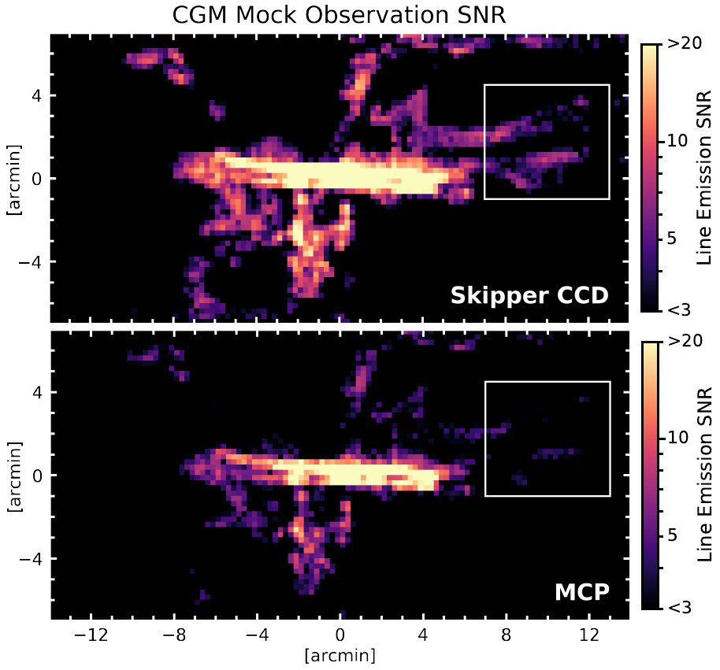Scientific charge-coupled devices, CCDs, are ubiquitous within the astronomical community, their invention revolutionizing the entire field. Current technologies allow for fast (< 30s) and low-noise (~1-2 electrons) image readout from CCDs, however even such impressive performances do not meet up to the demands of modern astronomical imaging. The UV quantum efficiency of current CCDs pales in comparison to other detector options, such as micro-channel plates. However, recent advancements means UV CCDs are beginning to take the place of older UV detectors. The MCP aboard Aspera [1] is capable of electron counting with high QE, allowing for direct imaging of the diffuse circumgalactic medium (CGM) around galaxies in OVI emission. Similarly, the electron-multiplying CCD (EMCC) aboard FIREBall-2 [2] is capable of electron counting with moderate QE to enable multi-object spectroscopy of CGMs. Both MCPs and EMCCDs suffer from binary electron counting-they are unable to distinguish between 1 and more than 1 electron. Moreover, MCPs require incredibly high voltages and suffer from high dark current. Skipper CCDs build on the traditional silicon CCD base, promising electron counting across the entire range: instead of reading out each pixel once, they non-destructively read out each pixel, allowing for numerous read outs of the same pixel, reducing the read noise by the square of the number of samples. This allows for incredibly high signal-to-noise ratios in both very diffuse regions and the bright regions around them, ideal for CGM studies. The improvement in read noise and its application to CGM measurements can be seen in Figure 1, which details the signal-to-noise ratio for both the Aspera Figure 1: Mock CGM observations including theoretical MCP and a Skipper CCD. Marked hypothetical signal to noise ratios of a current improvements can be seen in the diffuse MCP (bottom) and a theoretical Skipper CCD (top). regions where read noise dominates.

During my graduate studies at the University of Arizona, I have begun the characterization and testing of these Skipper CCDs. The Skipper CCDs sit inside a vacuum dewar, cooled to cryogenic temperatures, reducing the dark current and allowing us to measure the read noise. This dewar can be connected to a UV monochromator simultaneously with a calibrated photodiode, enabling us to measure the QE of Skipper CCDs at UV wavelengths down to 200 nm. Skipper read out is controlled via a Low-Threshold Acquisition controller, manufactured at Fermilab. By varying read out parameters, I am able to optimize the detectors for specific applications. After setting up this system, I can easily test and characterize new Skipper CCDs, allowing for immediate feedback for detector manufacturers. With added time, I will be able to develop a Skipper CCD platform that is ready for immediate on-sky application.

In order to create UV sensitive CCDs, multiple processing steps must occur. The detectors are thinned, allowing them to be backside illuminated. In collaboration with researchers at JPL, we then delta-dope the detectors-implant multiple narrow bands of dopants to decrease edge effects and increase quantum efficiency. Finally, we coat the detectors with a multi-stage anti-reflection coating. Together, these create near perfect internal quantum efficiency, limited only by the reflectivity of silicon.

After full characterization and noise performance evaluation of these Skippers, I plan to use them at existing telescope facilities to show their direct improvement over traditional CCD instruments. As an example, I plan to test our fully optimized Skipper platform at CHαS, the Circumgalacitc Hα Spectrograph, installed at the 2.4-meter MDM telescope [3], by observing previously characterized targets. Current observations are read noise dominated, as circumgalactic Hα only provides a few valuable photons to conduct science with.

**Research Timeline**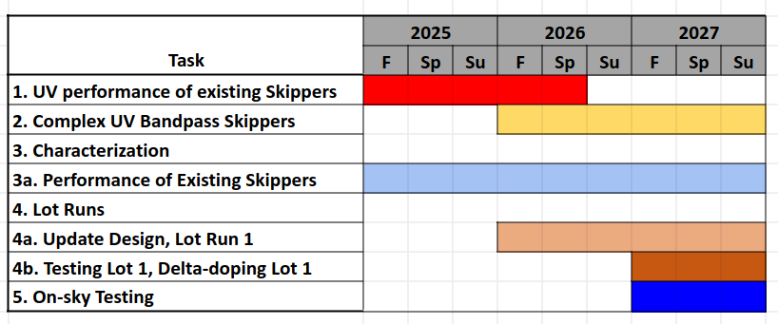

My proposed research timeline is detailed in Figure 2. I plan to continue testing existing Skipper CCDs for the next year, while planning the design and production of new Skipper CCDs and characterization over the next 2 years. In the final year, I plan to begin on-sky testing of these Skipper CCDs.

**Intellectual Merit** Figure 2: Proposed graduate research timeline Skipper CCDs promise advancements not only for CGM science, but for research in numerous areas in astronomy. High resolution spectrographs can use of Skipper CCDs and disperse the light across several detectors as there is little background noise. Similarly, high contrast coronographs need data is needed at both high signals and low signals, ideal for Skippers. Any field with very low signals, like exoplanet atmospheric characterization, benefit greatly from low nosie, high QE Skipper CCDs.

Specifically for the CGM, Skipper CCDs will help to constrain galactic evolution, star formation, the baryon budget, and gas dynamics as outlined in the 2020 Decadal. All of these goals are locked up in the “hidden” gas of the CGM, which is currently only accessible through line-of-sight observations toward background quasars, giving only small snapshots at the much greater CGM. The CGM is predicted to contain a significant fraction of the mass of the galaxy, as well as hosting all infalling and outflowing gas that feeds the galaxy’s star formation, necessitating its study.

Our team at the University of Arizona is uniquely qualified to conduct this research. Our team is well versed with UV instrumentation, including Dr. Erika Hamden, Dr. Carlos Vargas, and Dr. Haeun Chung, with missions such as FIREBall-2, Aspera, and CHαS. Additionally, Dr. Erika Hamden is well versed with UV enhanced CCDs, and collaboration between JPL is common. Arizona also includes numerous available resources, such as an existing UV/VIS dectector laboratory with an existing UV monochromator and previous EMCCD characterization experience. Moreover, the Imaging Technology Lab is uniquely familiar with the production and characterization of CCDs.

**Broader Impacts**

Skipper CCDs are uniquely suited to become the detector of choice for future NASA missions: specifically, the Habitable Worlds Observatory and LUIVOR, both requiring high QE, low-noise UV detectors. There is currently a stark lack of acceptable detectors, with no options offering all the required performance. Ultimately, aboard these observatories, Skippers will aid in measuring planetary atmospheres in the UV to determine if they can support life. Moreover, since Skippers function the same as regular CCDs, they can easily slot into existing instruments, improving the performance for practically no cost, providing an untold number of opportunities for new discoveries.

Throughout this process, the astronomical community will gain not only technology, but also scientists. This project will be in direct support of multiple undergraduate students’ research projects, through individual mentoring and lab shadowing through university funded programs.

[1]Chung, H., Vargas, C., Hamden, E., and Khan, A., “Payload Design of Aspera Mission: Detecting Warm-hot Circumgalactic Medium in Emission”, vol. 243, Art. no. 250.09, 2024.

[2]Hamden, E., “FIREBall-2: The Faint Intergalactic Medium Redshifted Emission Balloon Telescope”, *The Astrophysical Journal*, vol. 898, no. 2, Art. no. 170, IOP, 2020. doi:10.3847/1538-4357/aba1e0.

[3]Melso, N., “The Circumgalactic Hα Spectrograph (CHαS). I. Design, Engineering, and Early Commissioning”, *The Astrophysical Journal*, vol. 941, no. 2, Art. no. 185, IOP, 2022. doi:10.3847/1538-4357/ac9d9c.